Chapter 7, Solution 12.

Using Fig. 7.92, design a problem to help other students better understand source-free RL circuits.

Although there are many ways to work this problem, this is an example based on the same kind of problem asked in the third edition.

Problem

The switch in the circuit in Fig. 7.90 has been closed for a long time. At t = 0, the switch is opened. Calculate i(t) for t > 0.

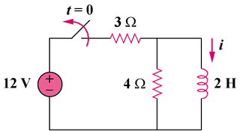

Figure 7.90

Solution

When t < 0, the switch is closed and the inductor acts like a short circuit to dc. The 4  resistor is short-circuited so that the resulting circuit is as shown in Fig. (a).
2 H
4 
(b)
3 
12 V

+
−
(a)
i(0⁻)
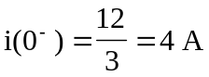
Since the current through an inductor cannot change abruptly,
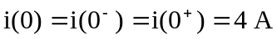

When t > 0, the voltage source is cut off and we have the RL circuit in Fig. (b).
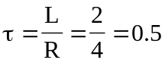
Hence,
